Consumer Preference and Buying Behavior Toward Packaged Tea
Brands in Bangladesh
This project was conducted to analyze consumer preference, purchasing behavior, satisfaction, and brand loyalty toward packaged tea brands in Bangladesh using statistical analysis techniques in SPSS. The study focused on understanding how consumers choose tea brands and how factors such as taste, packaging, advertisement, and income influence buying behavior in the FMCG sector.
A structured dataset consisting of 250 respondents was used for the analysis. The dataset was prepared for analytical and academic purposes based on realistic consumer purchasing patterns. Variables included demographic information (gender, age, occupation, income) and consumer behavior variables such as preferred tea brand, purchase frequency, advertisement influence, taste satisfaction, packaging satisfaction, brand loyalty, and recommendation intention.
Several statistical techniques were applied in the project, including Frequency Analysis, Descriptive Statistics, Crosstab Analysis, Chi-Square Test, Correlation Analysis, Independent Sample T-Test, One-Way ANOVA, and Reliability Analysis (Cronbach’s Alpha). The findings revealed that Ispahani was the most preferred tea brand among respondents, while taste and packaging satisfaction showed strong positive relationships with brand loyalty.
This project demonstrates how statistical analysis can be used to generate meaningful consumer insights and support market research and strategic decision-making in the FMCG industry.

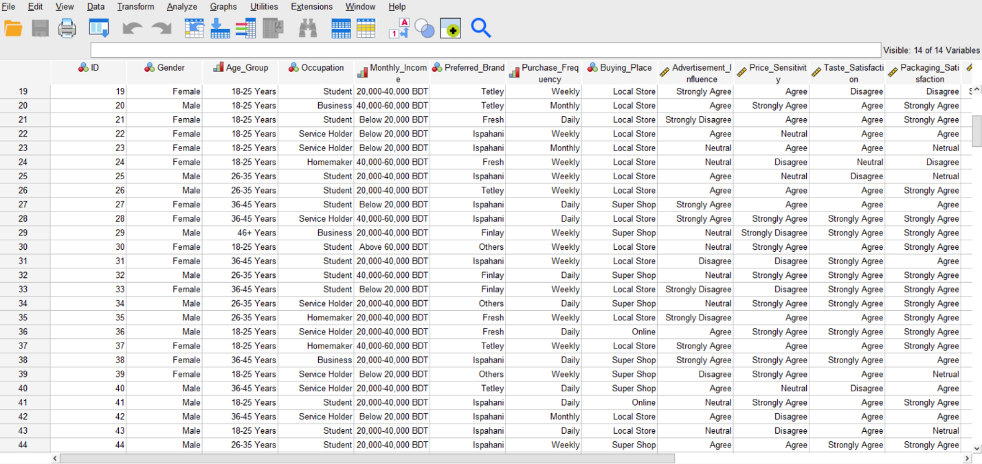
Data View

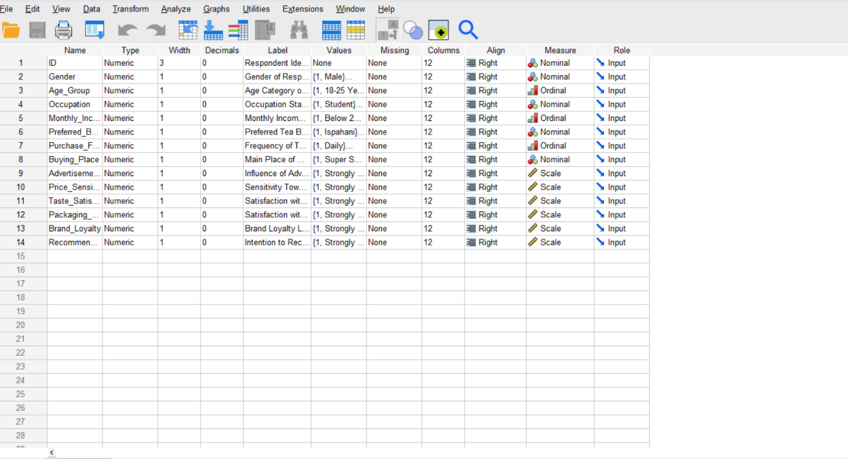
Variable View
Descriptive and Frequency Analysis:
Statistics
 |  | Gender of Respondent | Age Category of Respondent | Occupation Status | Monthly Income Category | Preferred Tea Brand | Frequency of Tea Purchase | Main Place of Purchase
N | Valid | 250 | 250 | 250 | 250 | 250 | 250 | 250
 | Missing | 0 | 0 | 0 | 0 | 0 | 0 | 0
Interpretation: A total of 250 valid responses were included in the analysis for all variables, with no missing data found in the dataset. This indicates that the dataset was complete and suitable for further statistical analysis.

Gender of Respondent
 |  | Frequency | Percent | Valid Percent | Cumulative Percent
Valid | Male | 142 | 56.8 | 56.8 | 56.8
 | Female | 108 | 43.2 | 43.2 | 100.0
 | Total | 250 | 100.0 | 100.0
Among the 250 respondents, 56.8% were male and 43.2% were female. This indicates that male respondents slightly dominated the study sample.

Age Category of Respondent
 |  | Frequency | Percent | Valid Percent | Cumulative Percent
Valid | 18-25 Years | 103 | 41.2 | 41.2 | 41.2
 | 26-35 Years | 88 | 35.2 | 35.2 | 76.4
 | 36-45 Years | 41 | 16.4 | 16.4 | 92.8
 | 46+ Years | 18 | 7.2 | 7.2 | 100.0
 | Total | 250 | 100.0 | 100.0

The majority of respondents (41.2%) belonged to the 18–25 years age group, followed by 35.2% from the 26–35 years category. This indicates that young consumers represented the largest portion of the study sample.

Occupation Status
 |  | Frequency | Percent | Valid Percent | Cumulative Percent
Valid | Student | 96 | 38.4 | 38.4 | 38.4
 | Service Holder | 91 | 36.4 | 36.4 | 74.8
 | Business | 34 | 13.6 | 13.6 | 88.4
 | Homemaker | 29 | 11.6 | 11.6 | 100.0
 | Total | 250 | 100.0 | 100.0

Most respondents were students (38.4%) and service holders (36.4%), while smaller proportions belonged to business and homemaker categories. This indicates that the study mainly represented young and working consumers.

Monthly Income Category
 |  | Frequency | Percent | Valid Percent | Cumulative Percent
Valid | Below 20,000 BDT | 67 | 26.8 | 26.8 | 26.8
 | 20,000-40,000 BDT | 105 | 42.0 | 42.0 | 68.8
 | 40,000-60,000 BDT | 56 | 22.4 | 22.4 | 91.2
 | Above 60,000 BDT | 22 | 8.8 | 8.8 | 100.0
 | Total | 250 | 100.0 | 100.0

The largest proportion of respondents (42.0%) had a monthly income between 20,000–40,000 BDT, followed by 26.8% earning below 20,000 BDT. This suggests that most respondents belonged to the middle-income group.

Preferred Tea Brand
 |  | Frequency | Percent | Valid Percent | Cumulative Percent
Valid | Ispahani | 113 | 45.2 | 45.2 | 45.2
 | Fresh | 54 | 21.6 | 21.6 | 66.8
 | Finlay | 38 | 15.2 | 15.2 | 82.0
 | Tetley | 31 | 12.4 | 12.4 | 94.4
 | Others | 14 | 5.6 | 5.6 | 100.0
 | Total | 250 | 100.0 | 100.0

Ispahani was the most preferred tea brand among respondents (45.2%), followed by Fresh (21.6%) and Finlay (15.2%). This indicates that Ispahani held the strongest consumer preference in the study.
Frequency of Tea Purchase
 |  | Frequency | Percent | Valid Percent | Cumulative Percent
Valid | Daily | 103 | 41.2 | 41.2 | 41.2
 | Weekly | 102 | 40.8 | 40.8 | 82.0
 | Monthly | 45 | 18.0 | 18.0 | 100.0
 | Total | 250 | 100.0 | 100.0
Most respondents purchased tea either daily (41.2%) or weekly (40.8%), while only 18.0% purchased tea monthly. This indicates that tea is a frequently consumed FMCG product among consumers.

Main Place of Purchase
 |  | Frequency | Percent | Valid Percent | Cumulative Percent
Valid | Super Shop | 90 | 36.0 | 36.0 | 36.0
 | Local Store | 140 | 56.0 | 56.0 | 92.0
 | Online | 20 | 8.0 | 8.0 | 100.0
 | Total | 250 | 100.0 | 100.0

The majority of respondents (56.0%) purchased tea from local stores, followed by 36.0% from super shops, while only 8.0% purchased online. This suggests that local stores remain the primary purchasing channel for tea products.

Descriptive Statistics
 | N | Minimum | Maximum | Mean | Std. Deviation
Influence of Advertisement | 250 | 1 | 5 | 3.60 | 1.018
Sensitivity Toward Product Price | 250 | 1 | 5 | 3.77 | 1.058
Satisfaction with Taste | 250 | 2 | 5 | 3.81 | .898
Satisfaction with Packaging | 250 | 1 | 5 | 3.74 | 1.098
Brand Loyalty Level | 250 | 1 | 5 | 3.76 | 1.021
Intention to Recommend Brand | 250 | 1 | 5 | 3.67 | .963
Valid N (listwise) | 250

The descriptive statistics indicate that respondents showed moderate to high agreement regarding advertisement influence, price sensitivity, taste satisfaction, packaging satisfaction, brand loyalty, and recommendation intention. Among all variables, taste satisfaction had the highest mean score (Mean = 3.81), suggesting that consumers were generally satisfied with the taste of their preferred tea brands. The standard deviation values indicate moderate variation in respondents’ opinions across all variables.
Charts:
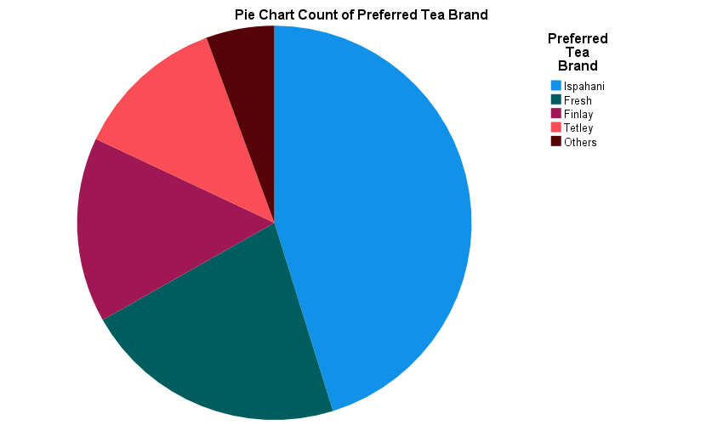
The pie chart illustrates the distribution of preferred tea brands among respondents. Ispahani occupied the largest portion of the chart, indicating that it was the most preferred tea brand among consumers, followed by Fresh and Finlay. This suggests that Ispahani holds a strong market preference compared to competing brands.

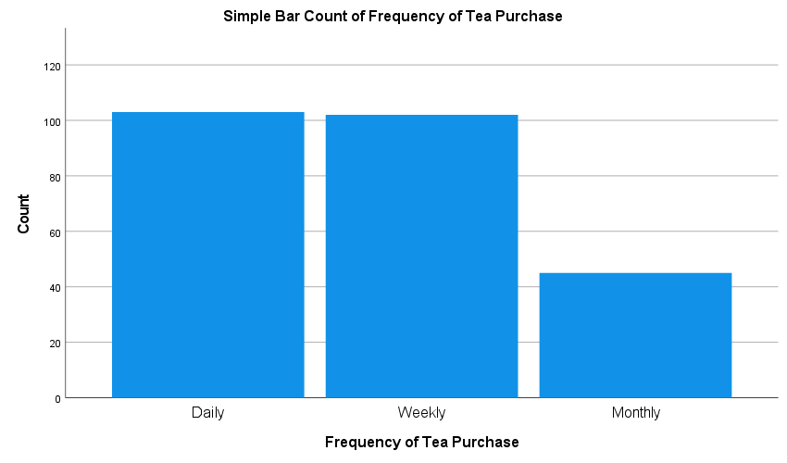
The bar chart shows that most respondents purchased tea either daily or weekly, while comparatively fewer respondents purchased tea monthly. This indicates that tea is a regularly consumed FMCG product among consumers.

Gender of Respondent * Preferred Tea Brand Crosstabulation
 |  |  | Preferred Tea Brand |  |  |  |  | Total
 |  |  | Ispahani | Fresh | Finlay | Tetley | Others
Gender of Respondent | Male | Count | 68 | 28 | 23 | 15 | 8 | 142
 |  | % within Gender of Respondent | 47.9% | 19.7% | 16.2% | 10.6% | 5.6% | 100.0%
 |  | % within Preferred Tea Brand | 60.2% | 51.9% | 60.5% | 48.4% | 57.1% | 56.8%
 | Female | Count | 45 | 26 | 15 | 16 | 6 | 108
 |  | % within Gender of Respondent | 41.7% | 24.1% | 13.9% | 14.8% | 5.6% | 100.0%
 |  | % within Preferred Tea Brand | 39.8% | 48.1% | 39.5% | 51.6% | 42.9% | 43.2%
Total |  | Count | 113 | 54 | 38 | 31 | 14 | 250
 |  | % within Gender of Respondent | 45.2% | 21.6% | 15.2% | 12.4% | 5.6% | 100.0%
 |  | % within Preferred Tea Brand | 100.0% | 100.0% | 100.0% | 100.0% | 100.0% | 100.0%

The Crosstab analysis shows that Ispahani was the most preferred tea brand among both male (47.9%) and female (41.7%) respondents. Although slight differences in brand preference were observed between genders, both groups showed a strong preference for Ispahani compared to other brands.

Chi-Square Tests
 | Value | df | Asymptotic Significance (2-sided)
Pearson Chi-Square | 2.174ª | 4 | .704
Likelihood Ratio | 2.166 | 4 | .705
Linear-by-Linear Association | .570 | 1 | .450
N of Valid Cases | 250
a. 0 cells (.0%) have expected count less than 5. The minimum expected count is 6.05.
The Chi-Square test result showed a p-value of 0.704, which is greater than the significance level of 0.05. Therefore, there was no statistically significant association between gender and preferred tea brand among the respondents.
Correlation Analysis:
Correlations
 |  | Satisfaction with Taste | Satisfaction with Packaging | Brand Loyalty Level | Intention to Recommend Brand | Influence of Advertisement
Satisfaction with Taste | Pearson Correlation | 1 | .731** | .707** | .280** | -.032
 | Sig. (2-tailed) |  | .000 | .000 | .000 | .609
 | N | 250 | 250 | 250 | 250 | 250
Satisfaction with Packaging | Pearson Correlation | .731** | 1 | .739** | .397** | .046
 | Sig. (2-tailed) | .000 |  | .000 | .000 | .471
 | N | 250 | 250 | 250 | 250 | 250
Brand Loyalty Level | Pearson Correlation | .707** | .739** | 1 | .463** | .015
 | Sig. (2-tailed) | .000 | .000 |  | .000 | .819
 | N | 250 | 250 | 250 | 250 | 250
Intention to Recommend Brand | Pearson Correlation | .280** | .397** | .463** | 1 | .450**
 | Sig. (2-tailed) | .000 | .000 | .000 |  | .000
 | N | 250 | 250 | 250 | 250 | 250
Influence of Advertisement | Pearson Correlation | -.032 | .046 | .015 | .450** | 1
 | Sig. (2-tailed) | .609 | .471 | .819 | .000
 | N | 250 | 250 | 250 | 250 | 250
**. Correlation is significant at the 0.01 level (2-tailed).

The correlation analysis revealed strong positive relationships between taste satisfaction, packaging satisfaction, and brand loyalty. In particular, packaging satisfaction showed the strongest positive correlation with brand loyalty (r = 0.739, p < 0.01), indicating that consumers who were more satisfied with packaging and taste were more likely to remain loyal to the brand. Additionally, advertisement influence had a moderate positive relationship with recommendation intention (r = 0.450, p < 0.01).
Independent Samples Test:
Independent Samples Test
 |  | Levene's Test for Equality of Variances |  | t-test for Equality of Means
 |  | F | Sig. | t | df | Sig. (2-tailed) | Mean Difference | Std. Error Difference | 95% Confidence Interval of the Difference
 |  |  |  |  |  |  |  |  | Lower | Upper
Satisfaction with Taste | Equal variances assumed | .117 | .733 | -.815 | 248 | .416 | -.094 | .115 | -.319 | .132
 | Equal variances not assumed |  |  | -.814 | 229.859 | .416 | -.094 | .115 | -.320 | .133
The Independent Sample T-Test was conducted to compare taste satisfaction between male and female respondents. Levene’s Test showed a significance value of 0.733, which is greater than 0.05, indicating that the assumption of equal variances was satisfied. The t-test result revealed a p-value of 0.416, which is greater than 0.05, suggesting that there was no statistically significant difference in taste satisfaction between male and female respondents.
ANOVA:
ANOVA
Brand Loyalty Level
 | Sum of Squares | df | Mean Square | F | Sig.
Between Groups | 3.962 | 3 | 1.321 | 1.271 | .285
Within Groups | 255.638 | 246 | 1.039
Total | 259.600 | 249

The One-Way ANOVA test was conducted to examine whether brand loyalty differed across different income groups. The result showed a p-value of 0.285, which is greater than 0.05, indicating that there was no statistically significant difference in brand loyalty among the income groups of respondents.

Multiple Comparisons
Dependent Variable: Brand Loyalty Level
Tukey HSD
(I) Monthly Income Category | (J) Monthly Income Category | Mean Difference (I-J) | Std. Error | Sig. | 95% Confidence Interval
 |  |  |  |  | Lower Bound | Upper Bound
Below 20,000 BDT | 20,000-40,000 BDT | -.115 | .159 | .889 | -.53 | .30
 | 40,000-60,000 BDT | -.058 | .185 | .989 | -.53 | .42
 | Above 60,000 BDT | -.480 | .250 | .224 | -1.13 | .17
20,000-40,000 BDT | Below 20,000 BDT | .115 | .159 | .889 | -.30 | .53
 | 40,000-60,000 BDT | .057 | .169 | .987 | -.38 | .49
 | Above 60,000 BDT | -.365 | .239 | .423 | -.98 | .25
40,000-60,000 BDT | Below 20,000 BDT | .058 | .185 | .989 | -.42 | .53
 | 20,000-40,000 BDT | -.057 | .169 | .987 | -.49 | .38
 | Above 60,000 BDT | -.422 | .256 | .355 | -1.09 | .24
Above 60,000 BDT | Below 20,000 BDT | .480 | .250 | .224 | -.17 | 1.13
 | 20,000-40,000 BDT | .365 | .239 | .423 | -.25 | .98
 | 40,000-60,000 BDT | .422 | .256 | .355 | -.24 | 1.09

The Tukey HSD post hoc test showed that all pairwise comparisons between income groups had p-values greater than 0.05. This indicates that there was no statistically significant difference in brand loyalty between any two income groups.

